Science Action Name: __________________

Heavy Finger
Question: What if I …

Materials:
- Two lightweight plastic glasses
- Water
- Pencil (not round type)
- Wood ruler (12”)
- Tape

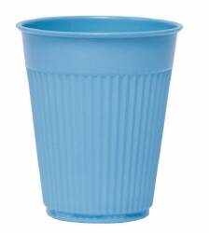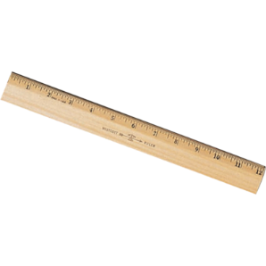

Procedure:
- Tape a pencil to table top
- Balance a ruler on the pencil
- Fill the two plastic glasses halfway with water
- Balance the glasses on the ruler
- Predict: What will happen if I put my finger in the water?
- Carefully place your finger in the water and observe.

Questions:
- What does it mean to balance?
- What is a prediction?
- Did your observation agree with your prediction?

